Task 3 Developing responses to a media product

SKYFALL
When watching the trailer for SKYFALL or even seeing the poster it is very clear what genera it falls under with the tone of the music helping, the costume design and the filters used.
James bond films are iconic as it is a well-dressed man in a suit drinking martinis and saving the day, I style compared to a film like full metal jacket where its more war loud guns and explosions.
If you were to walk into SKYFALL in the cinema and were only allowed to watch it for 5 minutes and tell what genera the film falls under you would be able to get it immediately without fail as there are genera codes for example:
Codes create meaning because they are a system of signs put in place. They are there to divide 2 different categories technical and symbolic.
James bond is a British Action film created by Ian Fleming and had its first release in 1953 (Casino Royale) its about the secret service in England (MI6) which is hidden from the public, the more modern films would include fast cars with guns ,special guns ,trackers and a lot of disguises to outsmart the enemy. All the posters used for publicity are mainly a man in a suit with a gun looking calm this shows class in the bond films and slickness.
Symbolic codes are the underwritten messages the company is trying to put out, the audience do not visually see the message because it’s beneath the surface what we see, a great example of this would be characters actions reflecting their feelings.
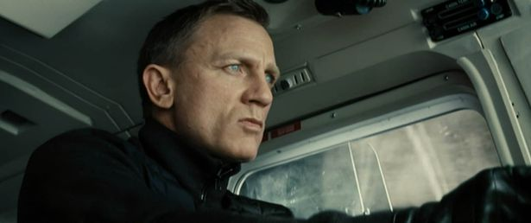
In this you can see Bond looking calm and professional this is to give off the illusion of him being a professional ,not loosing ,focused and motivated, from his eyes on the prize ,clenched jaw and facial reactions this give the camera a lot to work with and tells the scene a lot better.
Compared to a kids animated film you can see where the symbolic codes come into play:
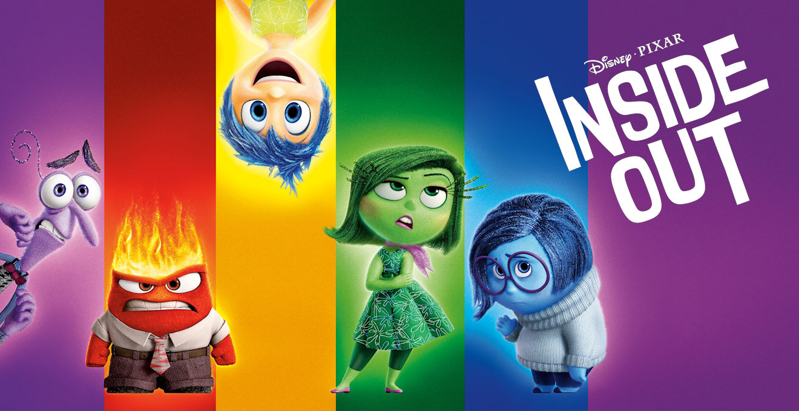
As you can see there are 5 characters all giving off a different expression as purple is fear, red is anger, yellow is joy, green is disgusted, and blue is sadness. As you can see all have different facial reactions from mouth, eyes eyebrows and body language.
Technical codes are the many ways in which the equipment Is used to tell the story, for example all the camera work in a film reflects the story ,going back to what I said about SKYFALL you could immediately tell what genre of film you are in. The film reflects the story because without it there would not be a story.
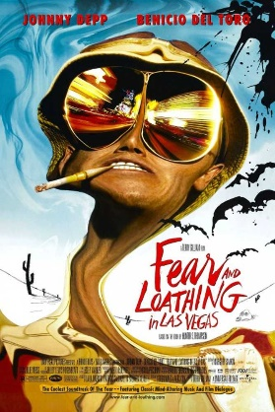Comedy 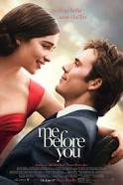Romance
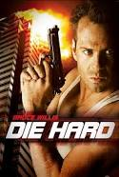Action 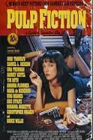Crime
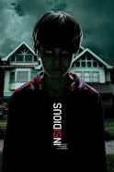Horror 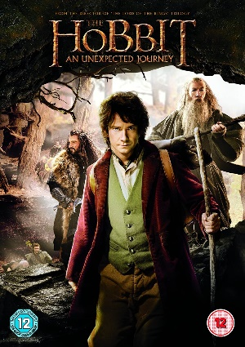Adventure
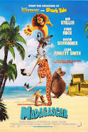Family 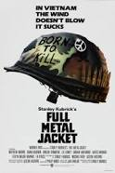War
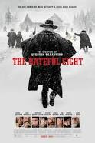Western

As you can see from the posters above they are all different and each have different styles and if you were shown a poster for a film you could 9 time out of 10 guess the film genre ,as well as this some come under 2 genres for example Madagascar falls under animation and family.
Codes and conventions are applied in the media studies through any genre.
Lighting is used as a technical code for example in horror films the back and side light is displayed to create a cold chilling effect ,mystery and eeriness which makes the audience feel scared and brace themselves for a jump scare, this is crucial in horror films. However in action films like sky fall the lighting is used as a technical code to made the good guys stand out with there secret layer which would be underground and dark but filed with tech and gadgets this is to give off the secret feeling and make the audience feel exclusive and part of the team.
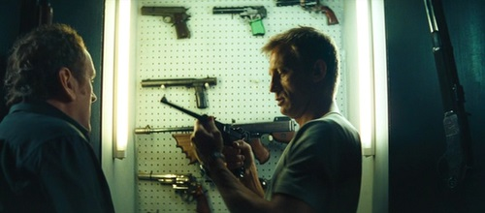
An action film which fails to generate excitement, tense and good protagonist more than likely will fail. It is key to understand what genera a film is aiming for as they need to base characters around the genre as this plays a key role in the film as if you were to replace James bond with a guy from a western it would work but not as well and make it fail as the gun fight would be off the costume design would not be right and the script would not suit it at all ,this is why a lot of genres will not mix and why a lot will as you have a rom-com which does really well compared to a western horror which it would not do well.
Genre Hybrid
A great example of this would be Cowboys & Aliens on paper is sounds ok it can only go 2 ways good or bad but this was a unusual cross over between western and science fiction, it was a unusual film to come out and left a lot of people sceptical weather it would work or not ,in the end it did ok the story line was ok ,the costumes were great and the actors were skilled but overall I would call this a fail due to the outcomes.
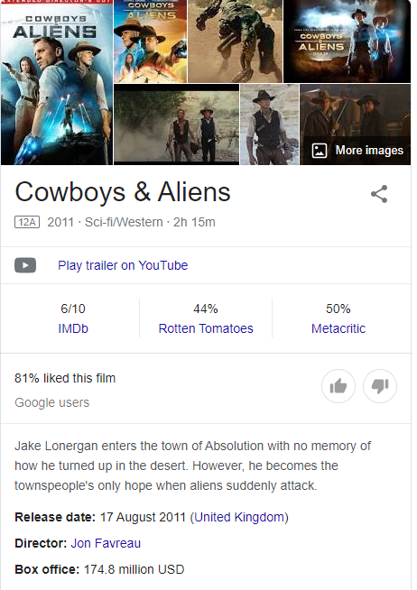
All though it did make good money on the box office it was not rated good on any sites and have comments like:
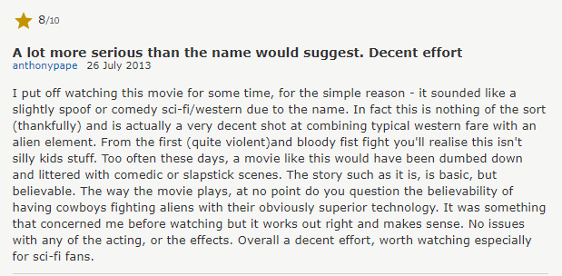
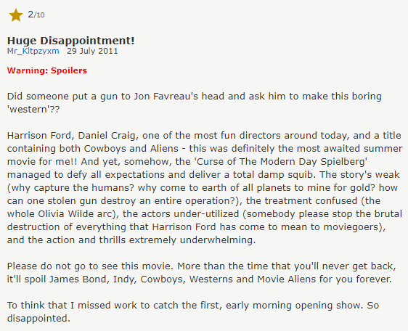
This then lead the team to not renew it for a 2nd film as it did poorly and did not meet targets they were hoping to make.
A crossover that did well would be The Spectacular Now which was a cross over between romance and come by ,the reason why this works so well as a lot of couple can relate to what going on compared to a western Sc-fi film, this is about how 2 unexpectable meet and become lovers and on the way they find problems and overcome them relating to a lot of couples this came out in 2013 and had made target and almost tripled there budget which is good but not the best.
As you can see, I have liked this film as I enjoyed it and found it great and would watch it again. But some people did not like it but overall it did ok for a film it did not fail which is key in the industry.
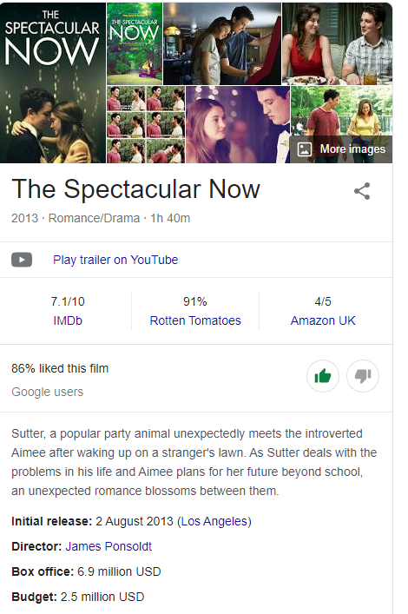
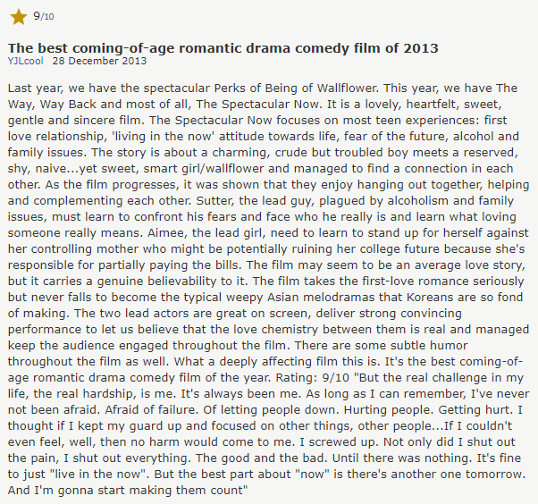
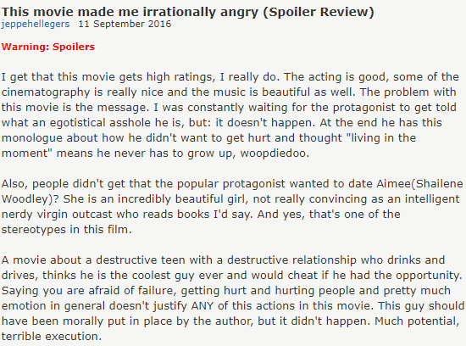

Action Fact Sheet
Definition “Action film is a film genre in which the protagonist or protagonists are thrust into a series of events that typically include violence, extended fighting, physical feats and frantic chases.” Wikipedia
Iconography
These are some of the element to expect in an Action Film:
- Hero – Villain
- Shoot outs
- Top secret weapons
- Expensive cars
- Car chases
- Getaways chances
- Capturing the villain and them escaping
- “Any last Words”
- Hero always coming out on top
Setting
Action films can have any number of settings, but these are most common

- Secret layer in the middle of no where
- Dark alleyway
- Expensive buildings

Narrative
There are a number of narrative concepts and tropes recur throughout the genre
- In action films the film makers draw upon a bad guy going to destroy the world or rule the world with a device and the good guy has to stop him before it’s too late and they normally end up stopping them at the last second.(Mission Impossible)
- Car chase with guns shooting and explosions going off ducking and weaving traffic. (Fast and Furious)
- Good guy gets captured and then escapes. (The Dark Knight)
- A final shoot off between the hero and villain. (The Matrix)
- Revenge on someone who hurt you or a love one. (John Wick)
- Damsel in destress

Style
Because this is aimed to generate tense and exciting moments in the audience, action films tend to express the film language with amplified scenes with louder more dramatic explosions and the music setting the tone wear if someone is shot it might play dramatic music showing there last moments on screen and build up rage for revenge in the hero or villain. As most action films are shown in the 3rd person you get to see all the surroundings they see. As well as if there meeting up with a acquaintance low key lighting is key as its secret. Cameras keeping up with smooth gliding tracking shots being used to create fear and that the hero is not alone and in a lot of danger, a lot of these shots are very well placed and constantly following the hero and sometimes loose sight of the villain to keep us unsettled and tense wondering what will happen next.
Music and diegetic sound effects are used to create this excitement in the audience and this dates back to the older action films and many films have there iconic sound effects or music from ‘James Bond’ to ‘Jaws’ ,the music generates a sense of excitement and makes the audience sit at the edge of there seats as they don’t know what’s coming. Sudden unexpected sounds might erupt on these soundtracks to generate tension diegetic sounds such as a car blowing up mid journey (Iron man 1) a building blowing up (SKYFALL) or someone shot out of nowhere (Bad Boys). Most scenes require a lot of nondiegetic sound as bullet sounds need to be made, explosions, helicopters, crashes and punches.
Diegetic Sound – Sound that is part of the film world such as dialogue, traffic, birds, bystanders etc
• Non-diegetic Sound – Sound added to create effect such as:
• Music soundtrack
• Theme Tune/Motif
• Sound Effects/Foley Sound – Sounds used to enhance diegetic sounds eg explosions, fighting
• Ambient sound – Sound that creates atmosphere– this could be diegetic or non-diegetic
In term of mise-en scene ,this is locations that may generate terror mostly this is where the hero would get caught out like in the desert, visiting a loved one or going about there day of retirement. Sometimes the location alone is to make it sound unsafe for example ‘The Dragon Island’ in chine there is a Komodo dragon pit showing its not a safe place for unexpected guests and that Bond is in danger and needs to be careful, as well as this most film directors would not show a scene like the Komodo dragon scene and not use it as the audience wants to see it in uses.
When editing filmmakers need to decide:
- What to keep and what to take away – CUTTING
- What order to put the shots in - SEQUENCE
- What happens between each shot - TRANSITION
- How long a shot remains on screen before changing to the next shot - PACE
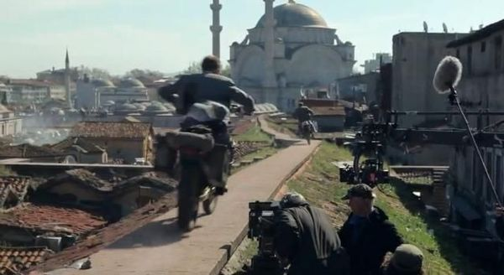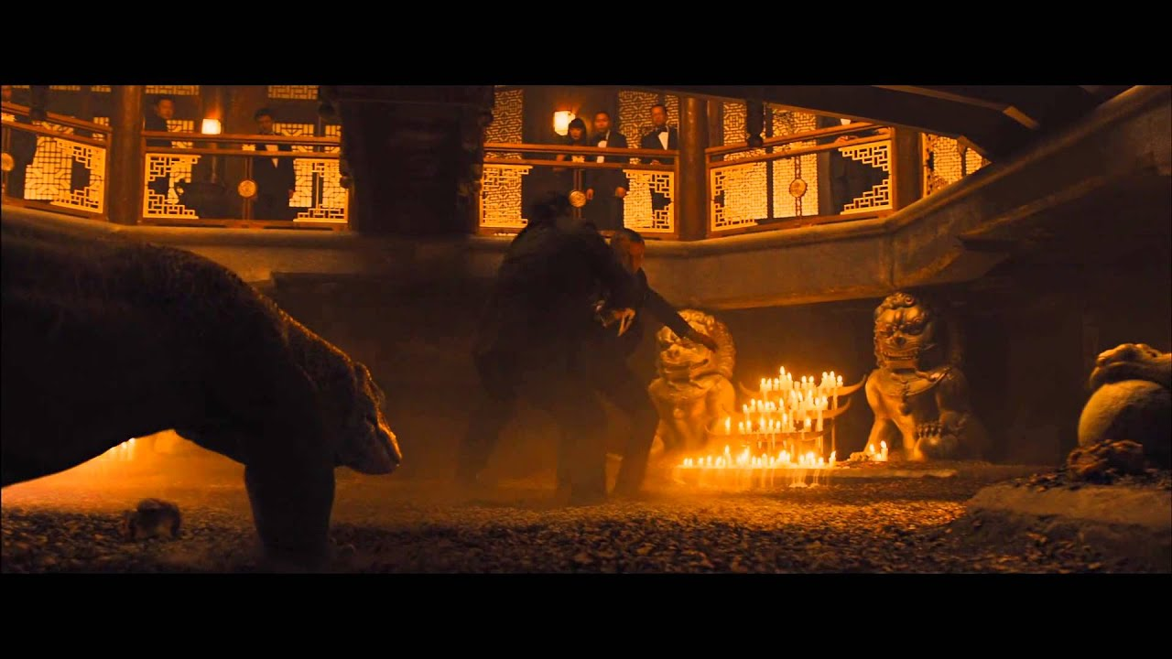
Characters
Typical characters may include:
- Special agents
- Retired top tier agents
- People wanting revenge
- Damsel in distress
- Villain
- Hero or group of heroes
- Anti-hero
- Action survivor
- Action-man or woman

Themes
- Bad guys and good guys outsmarting each other being 1 step ahead.
- Chasing from country to country
- Capturing and escaping
- Society in danger if someone is not stopped
- Good guy turning bad/rogue

Texts
Hero vs Villain
- Avengers
- James Bond
Action Adventure
- Indian Jones
Action Crime
- Legend
- Straight outta Compton
Buddy and Buddy
- Bad Boys
- Let’s Be Cops
Action Drama
- Top Gun
- House of the Rising Sun
Action Horror
- The Crow
- Hellboy
Disaster Film
- The Day After Tomorrow
- San Andreas
Spy Film
- Jason Bourne
- Miss congeniality
SOURCES
https://www.imdb.com/title/tt1714206/reviews?ref_=tt_ov_rt
https://www.imdb.com/title/tt0409847/reviews?ref_=tt_ov_rt
https://www.bbc.co.uk/bitesize/guides/zs8s9qt/revision/1
https://en.wikipedia.org/wiki/Action_film
https://www.mytutor.co.uk/answers/1621/GCSE/Media-Studies/What-is-the-difference-between-Diegetic-and-Non-diegetic-sound/
http://lordswoodmedia.weebly.com/uploads/3/0/6/5/30657339/action_adventure_mock_revision_booklet.pdf
https://en.wikipedia.org/wiki/Action_film
Google Classroom Notes
https://www.filmsite.org/actionfilms.html
https://www.nyfa.edu/student-resources/ultimate-list-of-film-sub-genres/

