Unit 23 Multi-cam Techniques

Live Event Shows, BBC news , Liverpool FC
Studio based productions, The Graham Norton Show, The Jeremy Kyle Show
Reasons For Multi Cam
There is many reasons for multi camera for example on “the Graham Norton show” there is the host ,guests ,audience and the band ,multi cam makes shows run a lot smoother and looks a lot better to the viewers at home as when Graham introduces a guest he gives a back story or upcoming events then it cuts to a different camera as the guest walks out from behind the curtain then cuts to a different camera showing the host and guest in one shot, this makes the production look a lot smoother than just one camera moving and shifting about the place and this is one of the main reasons why multi camera is more effective that single camera, this also has so much more coverage than just a single shot. Other reasons for multi camera is that it is a very effective for shooting television pragmas as when cuts to cameras it shows who’s talking and the main focus of events as it would look bad if the host was talking and the shot camera would be on the band as its ineffective and may turn viewers off of watching the show another example would be in a football match if a striker had the ball and was about to take a shot but the live camera was on the audience or referee it would be a bad production and get a lot of hate as they are missing the main shot and where all the viewers at the match would be looking with tense.
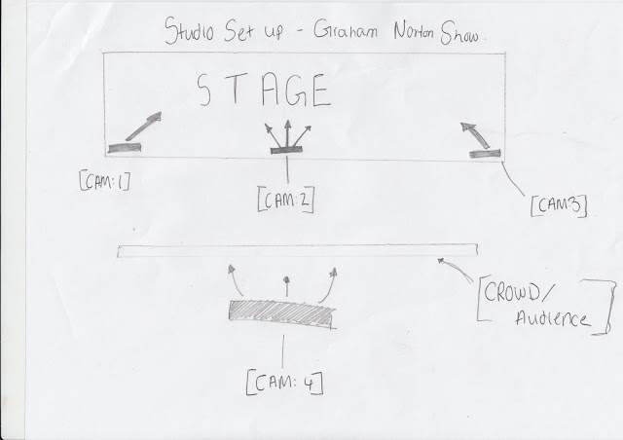
http://multicamera1.blogspot.com/2015/06/multi-cam-graham-norton-show.html
Communication meaning to the viewer
Communication meaning to the viewer meaning to the viewer makes them feel as if they are apart of the show/scene also making them feel as if they know everything that’s going on for an example the viewer shows the communication between the viewer and the show this can be seen in a drama series such as EastEnders Live ,as the visual of the multi camera productions is to help and let the audience understand and feel the same if they were actually watching the programs live a good example of this would be ‘Britain’s got talent’ where contestants would preformed on front of a audience and 4 judges and would be made into a tv show and broadcasted as they would be cutting to the judges for there reactions and the audience for there reactions and make it out to seem as if it live and engage the viewer to have an opinion weather they like or dislike the person and a lot of viewers with Britain’s got talent watch with their family members which brings the family together.
It is good to communicate with the viewer as it engages them and keeps there interest which means there watching there show longer which will evenatbly make them interested and have an opinion on what happing and if people at there work or friends watch it this makes it even more interesting as they can talk and discus it ,it becomes an area of interest and a enjoyment to watch and they cant wait for the next episode to come out.
Communication with the viewer is key as you want the audience to be engaged, watching and giving there opinion this will make the tv show do sagnifently better and make more money as well as this it will be shared about which will result in new viewers so in conclusion to Communication meaning to the viewer it is a key aspect to have in any television show.
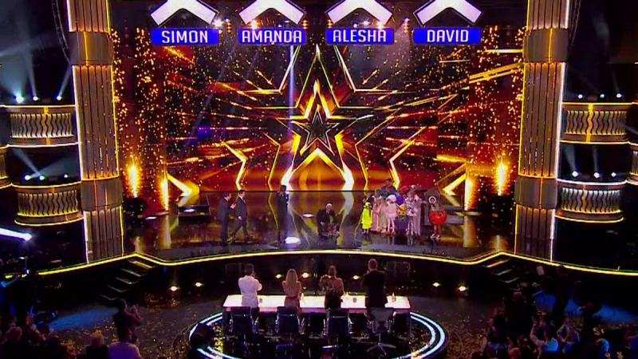
https://www.google.com/search?biw=1366&bih=667&tbm=isch&sxsrf=ACYBGNT8YvCBvS5b4fbe2q5lvJWyDMwSYg%3A1571906754765&sa=1&ei=wmSxXYWOLpDgUcGMkfgH&q=britain%27s+got+talent+live&oq=britain%27s+got+talent+live&gs_l=img.3..0j0i24l9.6910.7934..8327...0.0..0.79.370.5......0....1..gws-wiz-img.......0i67j0i30.buxShL8mtmU&ved=0ahUKEwiF9_L9wLTlAhUQcBQKHUFGBH8Q4dUDCAc&uact=5#imgrc=tRE-RiBWG4qxiM:

Visual style
The Visual style in multi cam production is to give the audience a shoulder to lean on and some help to have the same feeling as if they were actually watching the show live. A good example of this would be “The Voice” the contestants would show there them singing and the camera would be tracking them and mimic what is being shown and after the performance the camera on a boom would track the 4 judges and then tilt around to the singer ,if this is a tense moment the camera will contra zoom on the singer making the audience feel tense and if the singer is good and the audience is cheering the camera on the boom will pan around and pick up the laughter and encourage the viewer to laugh or cheer along.
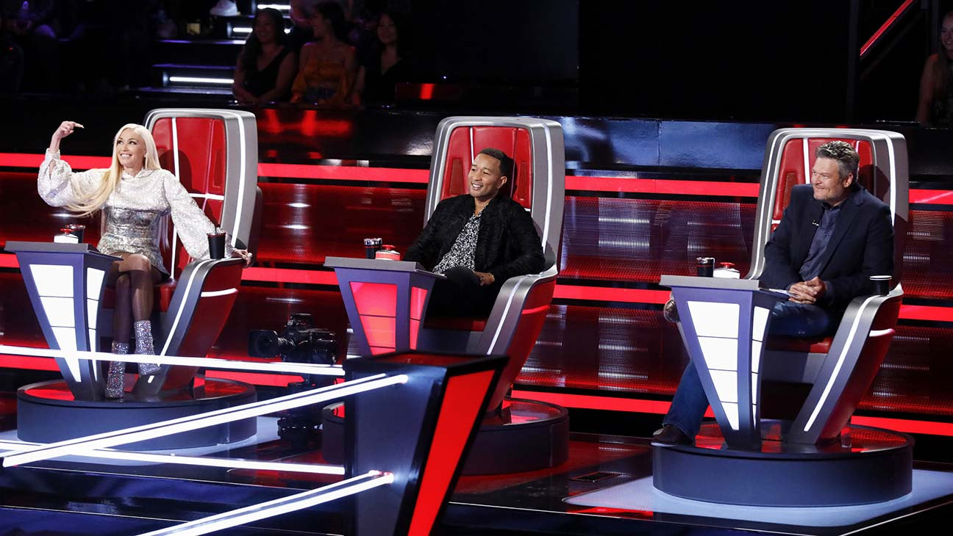
https://www.hollywoodreporter.com/live-feed/voice-recap-night-three-battles-ends-a-cliffhanger-1249192

Maintaining viewer interest
This means that all the elements of the multi camera production needs to come together to become a exquisite program to be entertaining and endurance to the viewer and keeps a hold of there time. a example of this would be “Strictly Come Dancing” the camera tracks the dancing duo on a boom while other camera focus on the judges, audience and because it’s a multi camera production there would be other camera on the dancing duo, when being viewed by the viewer the main focus will always be on the middle of the screen this shows the viewer what they should be interested in. cause its dancing the movement is fast and slow this depends on the music ,play style ,tempo and mood. Lighting is another technique as the lighting on the dancers and judges would be well lit and the audience would be dark and not well lit this makes the dancers and judges stand out and look better to maintain the interest of the viewer as they want to see the fancy dance moves and the expensive clothes.
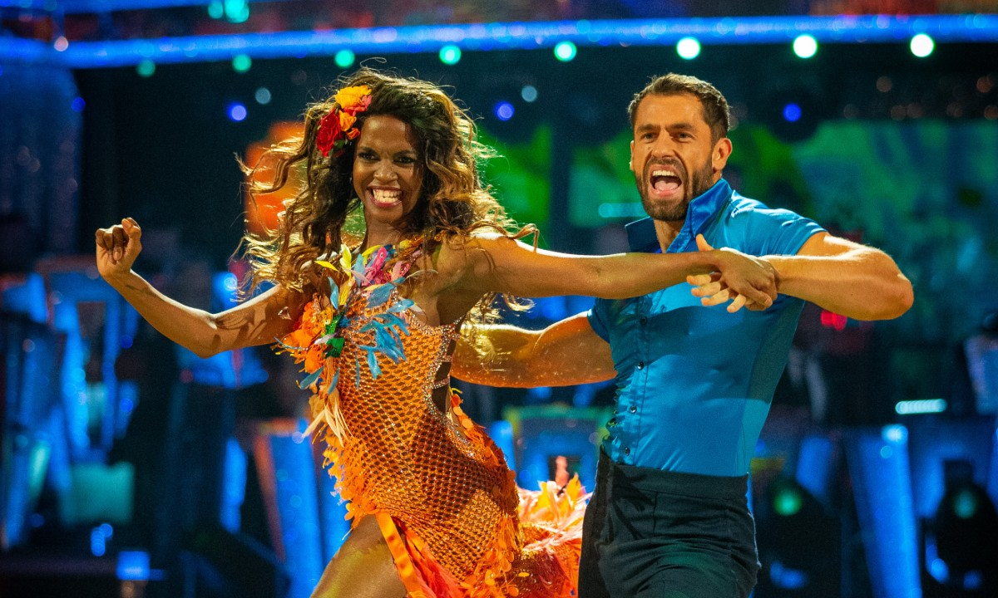
https://www.google.com/search?biw=1366&bih=667&tbm=isch&sxsrf=ACYBGNRxykH1QG9MY1PsimsSptkUpuQUow%3A1571906811159&sa=1&ei=-2SxXYKqCe2ajLsPs8ef-AE&q=strictly+come+dancing&oq=strictly+come+dancing&gs_l=img.3..0l10.68596.74570..75377...1.0..2.112.2185.28j1......0....1..gws-wiz-img.....10..35i39j0i67j0i131j35i362i39.u93znAu76yA&ved=0ahUKEwjCk-WYwbTlAhVtDWMBHbPjBx8Q4dUDCAc&uact=5#imgrc=0HrdtJPyC9WU6M:
Constraints of studio or location environment
Using the same constraints of a studio or location environment this can have a excellent effect a good example would be “Top Gear” have many cameras and many techniques around there studio this is so the cameras can make smooth cuts to and from cameras for an example a camera on a car could swiftly cut to the camera panning around the audience for there reactions. This will make taking and showing off cars a lot easier. The studio never changes as well its always the round stage with car seats on it, the audience and the view from in the car which makes it even easier to show off the cars and there body language.
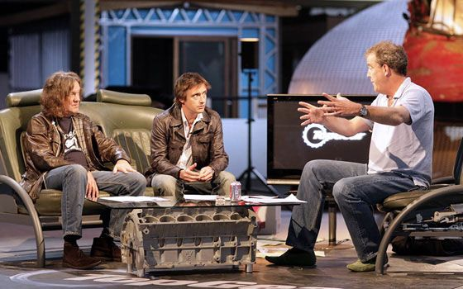
https://www.google.com/search?biw=1366&bih=667&tbm=isch&sxsrf=ACYBGNTAtJTQYaX8KQvNYWY7nCa3LhywqQ%3A1571907035960&sa=1&ei=22WxXbGYOqXlgwfgooToBQ&q=top+gear+couch&oq=top+gear+cou&gs_l=img.3.0.0l2j0i8i30j0i24l7.5459.7562..9874...0.0..0.94.352.4......0....1..gws-wiz-img.FrxMNQi4vPg#imgrc=0OKTv3ySn-WhKM:

Multi cam simultaneous recording
This is where there is multiple cameras and transitions between all camera this would be like a quick switch, fade or cut, this is to make all cameras look as smooth as possible and make it relevant to the show. A program who does this amazingly is “Dancing on Ice” as the cameras follow the skaters all over the floor on booms and cranes, this shows all angles, so the audience sees all aspects of the dance. They use several cameras to do this to make it as best they can as possible. As well as this dancing on ice is very unique when filming as they have specific gimbles made for a camera man to use when he ice skates along with the dancers this is to get close up and unique angles any other camera would not get.
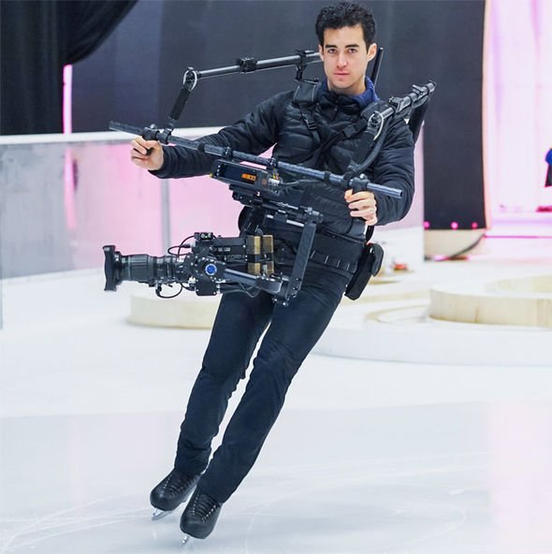

Talk about the intoto the tv shows
Contazoom tracking panning tilting
Sources
https://shenikaprincess.wordpress.com/multi-camera-techniques/
https://prezi.com/f-5fbphxw1c5/unit-23-multi-camera-production/

https://prezi.com/f-5fbphxw1c5/unit-23-multi-camera-production/

